Market Basket Analysis Report

The purpose of this report is to inform whether or not it would be good idea for Blackwell Electronics to acquire a start-up electronics online retailer, Electronidex. Market Basket Analysis was the primary analytics technique used to explore the aforementioned business problem. This report will explore the following questions, using visualizations where relevant. Finally, this report will outline any observations or recommendations.

* Q1 - Are there any interesting patterns or item relationships within Electronidex's transactions?
* Q2 - Would Blackwell benefit from selling any of Electronidex's items?
* Q3 - In your opinion, should Blackwell acquire Electronidex?
* Q4 - If Blackwell does acquire Electronidex, do you have any recommendations for Blackwell? (Ex: cross-selling items, sale promotions, should they remove items, etc.)

Graph showing the top 20 most frequent items

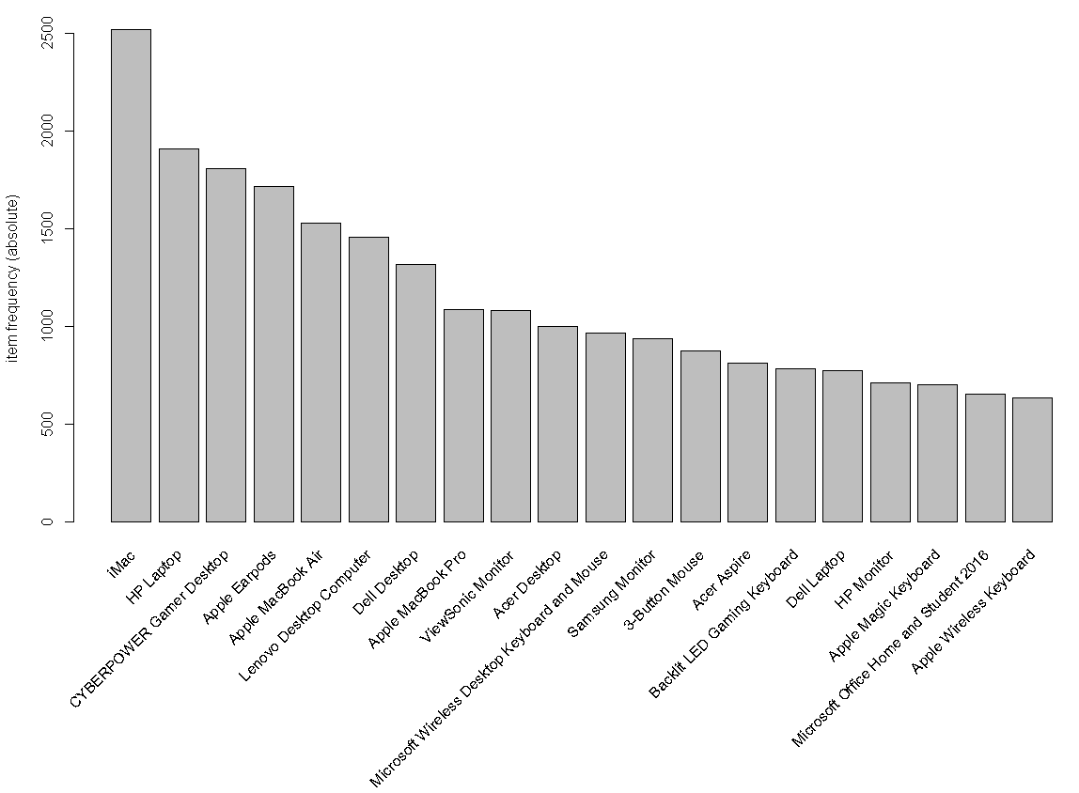

Section Q1

The majority of the top 20 most frequent item purchases from the Electronidex transactions dataset featured items computers (mostly laptops and some desktops) and computer peripherals (mouses, keyboards, monitors, etc.) Within this range of items, the top five items were: *iMac, HP Laptop, CYBERPOWER Gamer Desktop, Apple Earpods* and *Apple MacBook Air*. These five items account for about 22% of total items purchased (9,482 out of 43,104 total items). An immediately important insight from this is that Apple products are very popular, making up 60% of the top five most frequent items. A majority of transactions involved between 1 and 4 items.

Using Market Basket Analysis, I created several rules. These rules are meant to express possible purchasing behaviors. For example, if a customer purchases eggs, milk, sugar and flour, they may also purchase icing, sprinkles or party hats. To be absolutely clear, rules from Market Basket Analysis are not predictions regarding what customers will purchase. They are only meant to represent possible associations between items, which may later be used to inform possible purchasing behavior given additional analysis and marketing efforts*.*

In total, my analysis saw the creation of 48 rules all of which show different possible purchasing relationships between different electronic goods. These are the following companies whose products were featured in the created rules, in no particular order: Apple, HP, LG, ASUS, Acer, Lenovo, Dell, CYBERPOWER, ViewSonic and Microsoft software (Microsoft Office suite).

Having said that, given these rules, it appears that Apple products appeared the most frequently. That means that, if a customer buys a product from any of the aforementioned companies, they may also purchase an iMac. In the cases when a customer may already be purchasing an Apple product, my rules indicate that such customer may also purchase an HP Laptop. Having said all of that, my created rules following this format: LHS (2-3 items) -> RHS (1 item) --- What this structure conveys is that when two or three items are purchased (LHS), an additional item (RHS) may be purchased alongside those other two or three items. Again, these rules are mere association, not predictions or definitive facts of what a customer will purchase. My rules indicate that iMacs are the most frequent item that could be a possible additional purchase (RHS) associated with the purchase of two or three other prior items (LHS). When iMacs are not the possible additional purchase (RHS), then HP Laptops are. Those most frequent category of those two or three items (LHS) involve other laptops, monitors, desktops, mouses, monitors, Earpods, keyboards and software (as mentioned earlier in this report). A large majority of the created association rules feature a desktop or laptop of some kind, either in the form of a LHS item or a RHS item.

Ultimately, my created association rules express that possible transactions may involve core computer-related hardware. More specifically, desktops and laptops are highly featured, which may indicate that these items are potentially very popular consumer goods, regardless of brand or company. But again, Apple products appear to be the most frequent regardless if such products are LHS or RHS. Given my analysis, we may conclude that Apple products may be popular company/brand for customers.

Visualization of Association Rules (showing only 15 out of 48 rules)

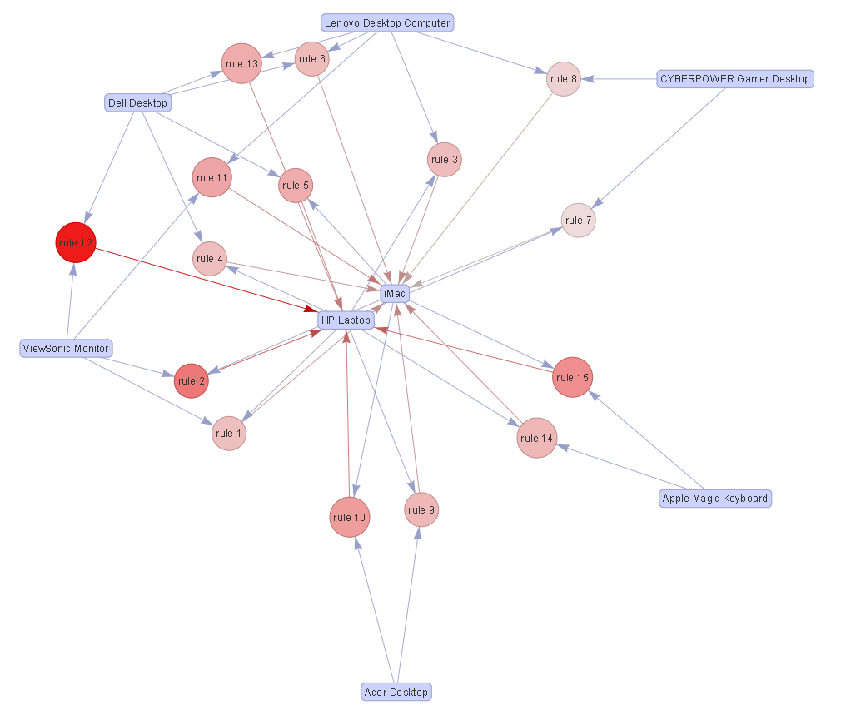

The above graph visually represents the association rules, expressing only 15 out of 48 rules, based on the Electronidex transactions data. Arrows pointing to items, such as HP Laptop and iMac, mean that said items are RHS (which means that they are the possible additional item that could be purchased alongside other prior items). Items that point to rule nodes are LHS (which means that they are possible items that a customer has already planned to purchase). As outlined earlier in this report, the structure of this graph is LHS -> RHS. The size of the rule nodes represents the “support” metric, while the color of such nodes represents the “life” metric. Association rules are evaluated by three metrics: support, confidence and lift. These metrics are important in determining whether or not association rules are to be kept, discarded or require changes to the Apriori Algorithm which is used to create such association rules.

Section Q2, Q3 and Q4

Given my analysis above, I cannot answer the question as to whether or not Blackwell Electronics should acquire Electronidex. Moreover, I cannot answer the question as to whether or not Blackwell Electronics should start selling items featured in the Electronidex transactions dataset. The primary reason for my inability to answer these two questions is because Market Basket Analysis, alone, is not sufficient in determining the business strategy associated with acquisitions. I say this for the following concerns, in no particular order of importance: 1) there is no direct data indicating the performance and possible growth for Electronidex + 2) Electronidex is a startup company which means it is inherently fragile whereas Blackwell Electronics is an established company – the two companies, therefore, have two different logistical challenges and operating concerns + 3) Given the latter reasons, it is not clear to me how might Blackwell Electronics deal with the incurring the expenses and financial obligations of Electronidex – that is, there is no way of knowing if Blackwell Electronics could remain financially viable if it incurs additional expenses or may even start operate under losses given having to channel resources to the fledging Electronidex that it would now be responsible for --- ultimately, regardless of the veracity of these three reasons, my primary reason is that Market Basket Analysis simply cannot resolve or answer the issue of acquisition. Additional information and insights are needed to make an informed decision on that front.

That being said, Market Basket Analysis may appear to be potentially be more useful in informing Blackwell Electronics’ business strategy as it relates to its inventory. That is, my analysis clearly indicates that HP laptops and iMacs could be sold more given cross-selling and product placement techniques. This is because these items are frequently paired with additional items. Intuitively speaking, customers are likely to buy an entire suite of computer hardware. That is, they are likely to buy mouses, keyboards, monitors, speakers, desktops (for stationary use) and laptops (for mobile use). Moreover, when it comes to electronic goods, customers tend to value quality, longevity, brand popularity and customer/accessibility support. As such, in my opinion, this further reinforces the sheer representation of HP and Apple products. HP and Apple are widely known, well-established companies which has the infrastructural and reputational conditions to be well-believed by customers. To really ascertain how useful it could be for Blackwell Electronics to sell products featured in the Electronidex dataset, it would be necessary to consider the following: 1) sales volumes of items, 2) customer demographics associated with purchases, 3) operational costs associated with distributing items, 4) data and insights, direct and indirect, that approximate customer demand.

While I can’t strongly answer, one way or the other, whether or not Blackwell Electronics should acquire Electronidex or start selling its items, I would recommend the following: 1) performance data and insights for Electronidex is obtained and considered + 2) Blackwell Electronic consider and develop a business (financial) strategy in taking up the expenses and operational challenges that Electronidex has + 3) Blackwell Electronic consider leveraging its customer demographic data and insights (see outcomes from Course 1) and ascertain how might HP laptops and iMacs may relate to certain types of customers (for example: mobile, tech-savvy, college-aged/young professionals who may have access to disposable income and a wiliness to follow tech trends). Ultimately, Market Basket Analysis is illustrative in possibly understanding how purchasing behavior can be affected but such insights need to be coupled with the principles of customer understanding and marketing in order to generate strategies of cross-selling, up-selling, promotional sales, and so on.